Janis Gonzalez

WEB 420 RESTful APIs

Discussion 3.1 Describing an APIwith an API Description Format

March 30,2023

Bellevue University

API stands for Application Programming Interface, which is a software that allows two applications to have interaction with each other. It is software that can be used by other software to use as communication between other software and hardware. An application programming interface acts as sort of a liaison between the different software and devices. In order to be able to identify an API’s goals from the consumer’s perspective one should start by understanding three points of the customers. The first point would be who the customer is. The second point would be what the customers’ needs are, what tasks they want to accomplish, what benefits they enjoy and what circumstances they face (Biehl, 2022). It is essential to create an API that fits the needs of the consumer and not create something that is not needed or asked for. It is important to create empathy and understanding for the consumer and the challenges they face. This means that engagement with the consumer is a must to get to know who they are and what they need. This step is about getting to listen, understand and learning about the consumer. The third point would be to understand how the API can fulfill the needs of the consumer as well as improving the tasks and creating benefits for them (Biehl, 2022). A good way to help transpose these goals into a programmable representation would be to first visualize and evaluate the data gathered. This can be done by creating an API Value Proposition Canvas which helps provide structure to describe an API customer profile with a matching API product (Figure 1) (Biehl, 2022). OpenAPI Specification, or OAS, is the industry-standard specification that outlines how an OpenAPI file should be structured (De Wilde). The OpenAPI Definition is a file that represents the specific API use and is machine-readable and represented in either YAML or JSON format (De Wilde). An API Documentation is the visual, human-readable representation of an API structure and uses HTML, CSS and JavaScript. The OpenAPI file includes an info portion that contains crucial information about the API such as title, license, summary and version (Oai). It would look like (Oai):

openapi: "3.0.0"  
info:  
 version: 1.0.0  
 title: Swagger Petstore  
 license:  
 name: MIT  
servers:  
 - url: http://petstore.swagger.io/v1  
paths:  
 /pets:  
 get:  
 summary: List all pets

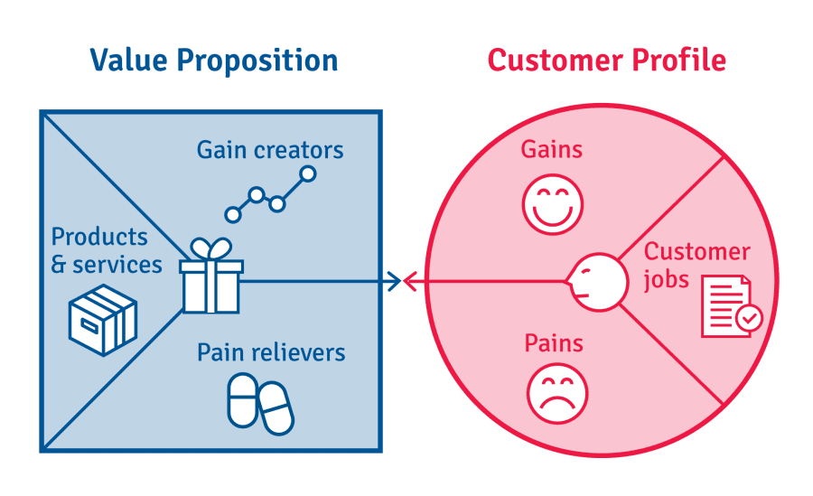  
Figure 1 (Biehl, 2022).

References

Biehl, M. (2022, November 15). *Don't start with your API, start with your customers*. Software AG. Retrieved from <https://blog.softwareag.com/api-economy/>

De Wilde, G. (n.d.). *What is OpenAPI? Introduction to OpenAPI Specification (OAS)*. Apideck. Retrieved from <https://blog.apideck.com/introduction-to-openapi-specification>

Oai. (n.d.). *OAI/openapi-specification: The openapi specification repository*. GitHub. Retrieved from <https://github.com/OAI/OpenAPI-Specification>